**Enhancements / Modifications Punchlist:**

**Steps:**

* **1st Convert from Enigma from qsocks (Dennis) (complete)**
* **Setup Dev GitHub for Cloudera Data Explorer (PE - Chris)**
* **Code Review before handover (Webex) – after SKO (complete)**
* **Prioritize Features & Rank & Bucket (Dave) (complete)**
* **Deploy to Github and start dev (create feature packages for releases)**
* **Target release end Q1 for new baseline (version?)**

**Parallel Track – Dave talk with Matthias about QMI setup, adapt for launch…**

**Rank of Priority Upgrade:**

**1) Multi-table select scrtipt fix (Enhancement F)  
2) Auto-select/populate columns upon table selection (Enhancement A)  
3) Edit script in review section (Enhancement G)  
4) Final Page Metrics/Review (Enhancements B/C)  
5) Add Search Bar to selection screen (Enhancement H)  
6) Allow creation of session app (Enhancement I)**

**Rank of Priority Bug Fix:**

**1) Fix limit/filter on multiple tables issue (Fix D)  
2) Fix Direct Discovery (Fix E)**

**A. Enhancement: Auto Select all possible? – suggestion, use Vizlib filters**

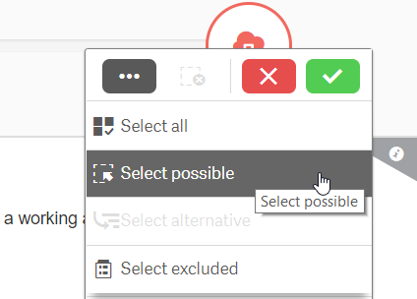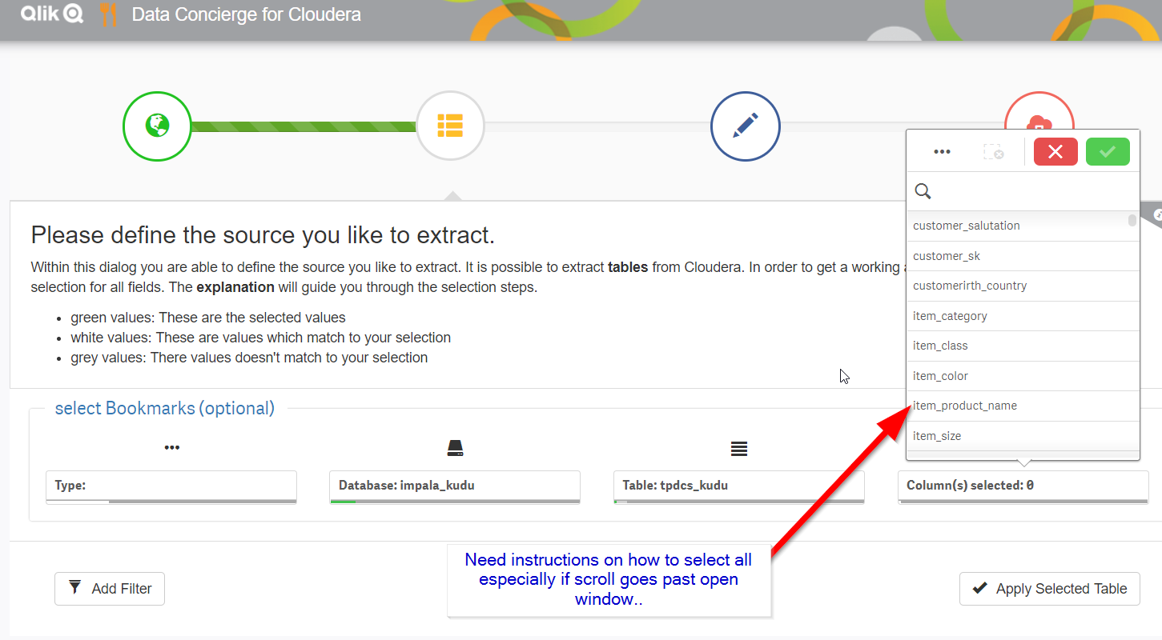

**B. Enhancement: Enhance Final page with stats/metrics/data profiling? Make the chart useful.**

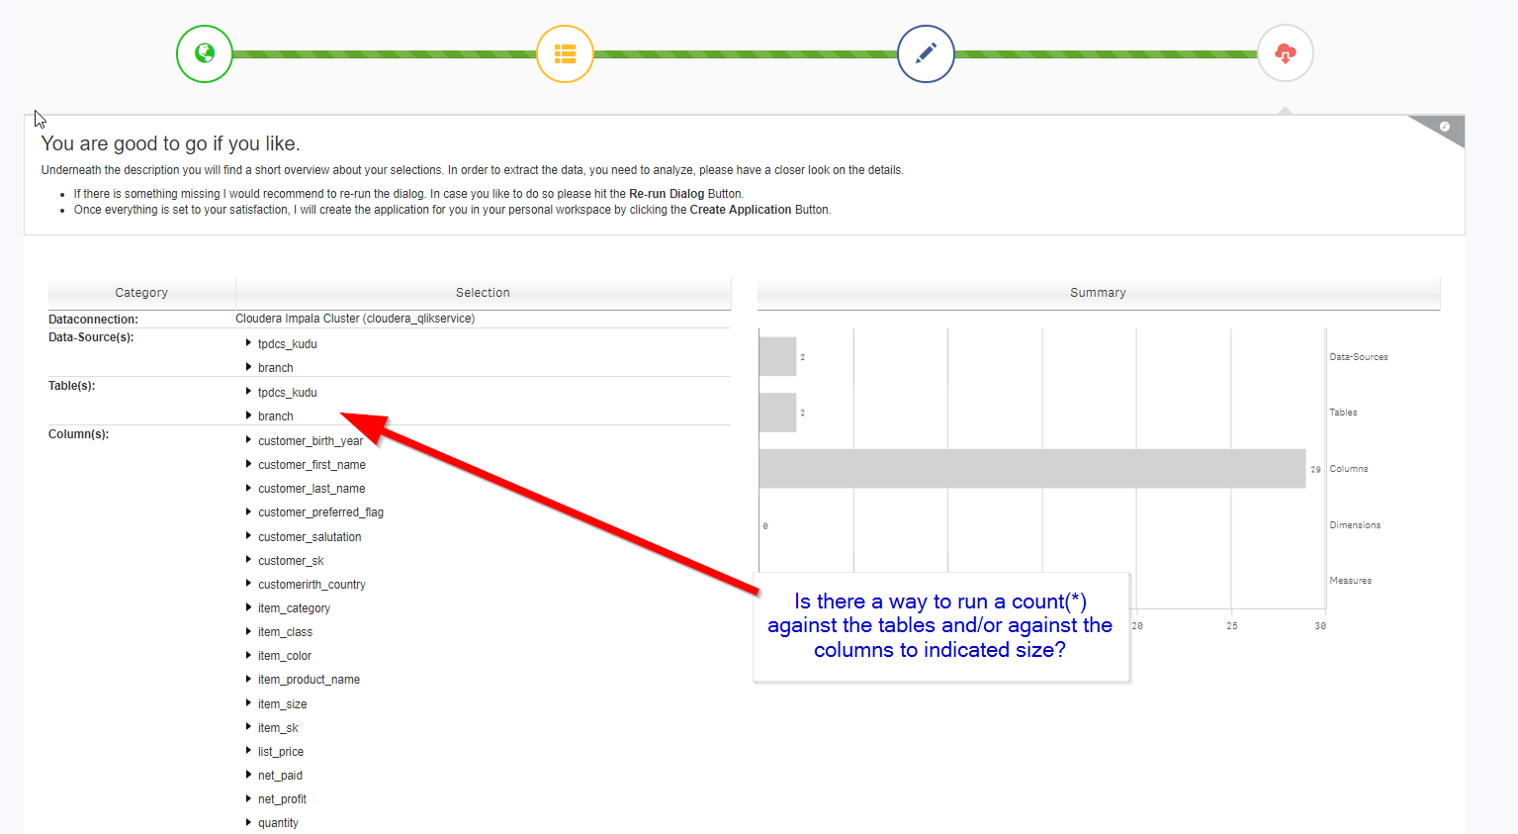

**C. Enhancement: Filter updates record counts?**

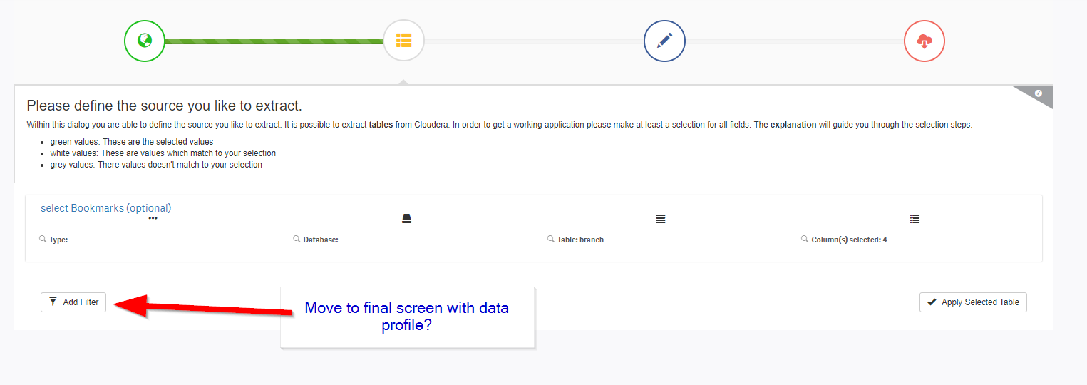

**D. Fix: current issue with LIMIT/FilFixter applying to individual tables….**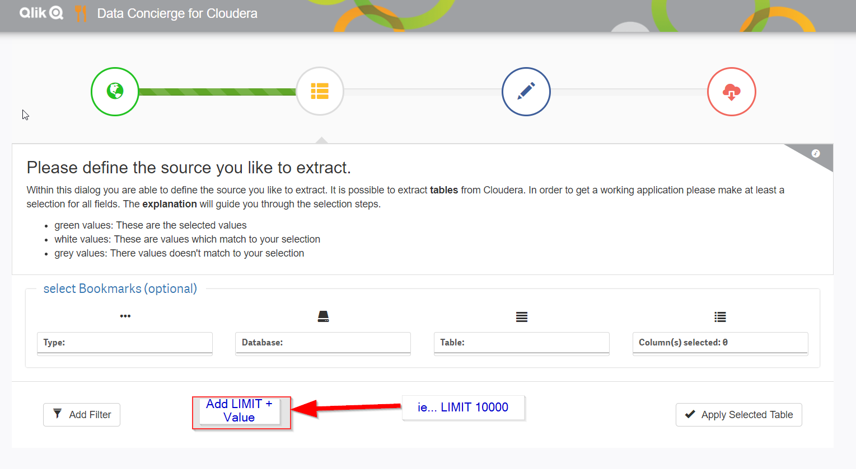

**E. Fix Direct Discovery  
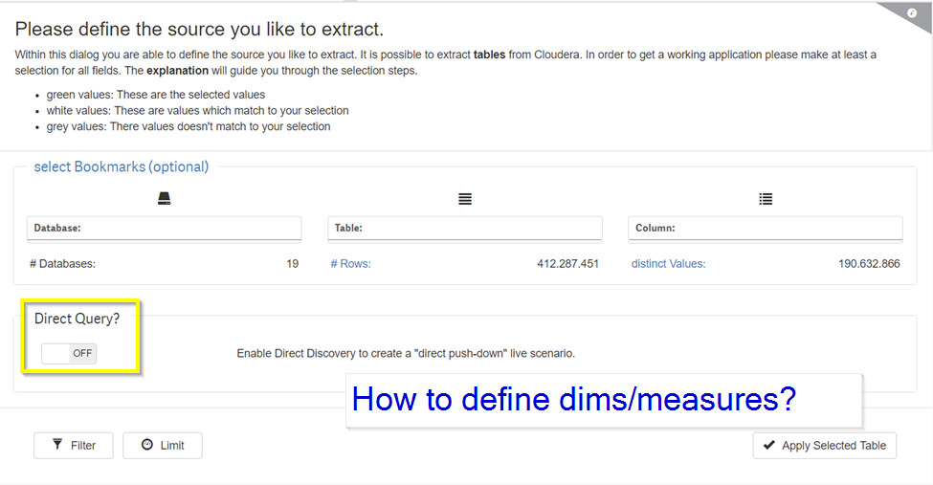**

**F. Enhancement: Allow multi-table selection, fix logic to split in script creation.**

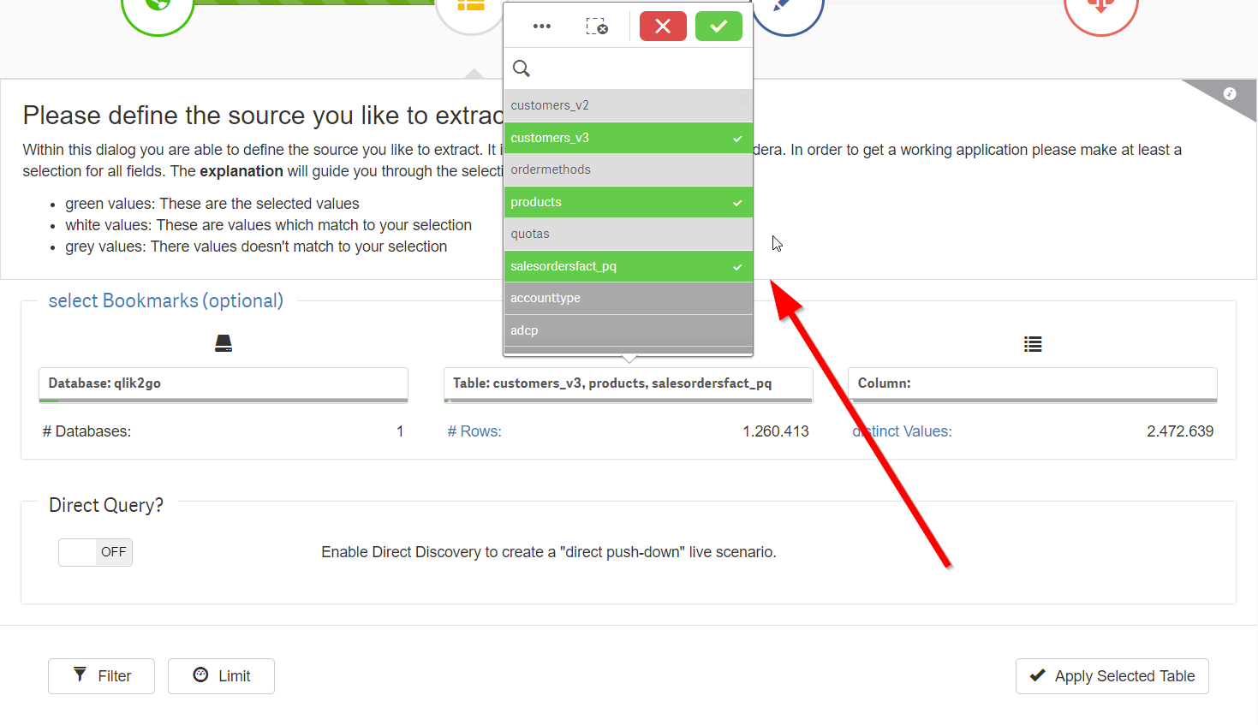

**G. Enhancement: Add more info to Source Review Screen? Allow creation master items? Select dims/measure direct discovery?**

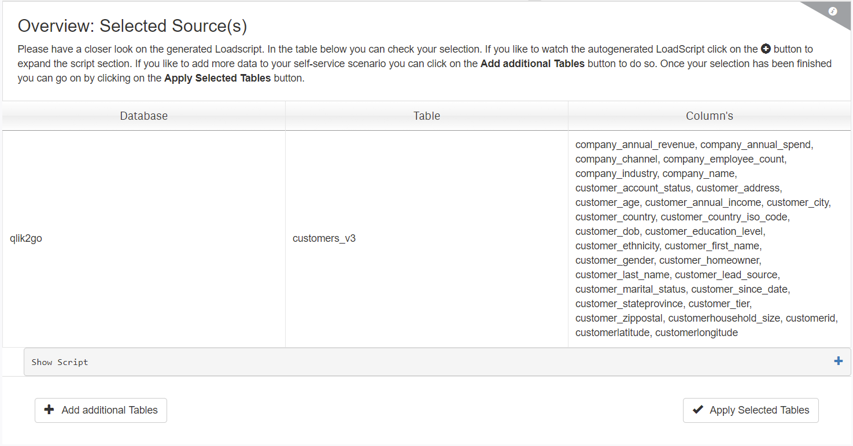

**H. Enhancement: Add search bar to start screen**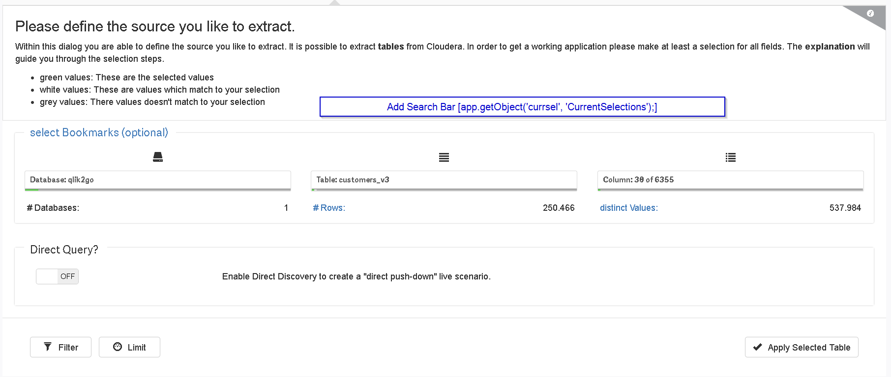

**I. Enhancement: Add Session App Option to Launch Apps**

